Test Case: tc005_SPX_Dev5_Crear_Requisicion_Spot_Con_FAD_Tipo_Cobro_Project
Step 1 - Enter username and password and click to button Enter: Credentials Entered
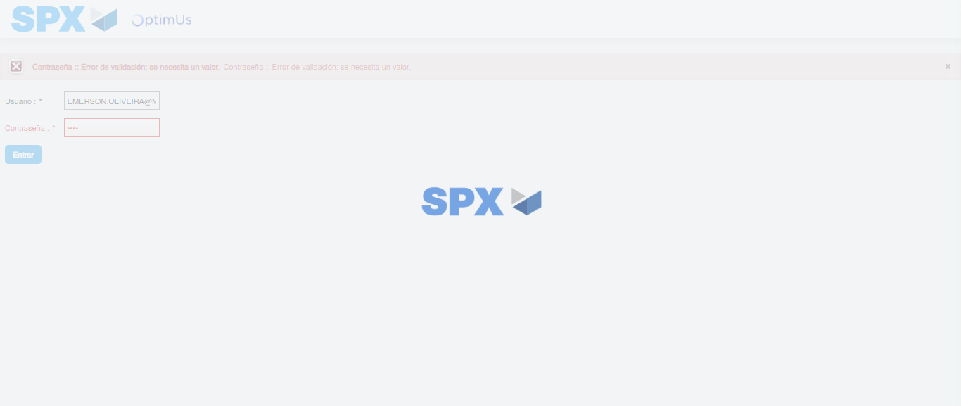Image file-name: QC_Testing-tc005_SPX_Dev5_Crear_Requisicion_Spot_Con_FAD_Tipo_Cobro_Project-1784669166377

Step 2 - Select to UEN and Access to Spot Buy Requisitions : UEN Correctly selected and Correct access
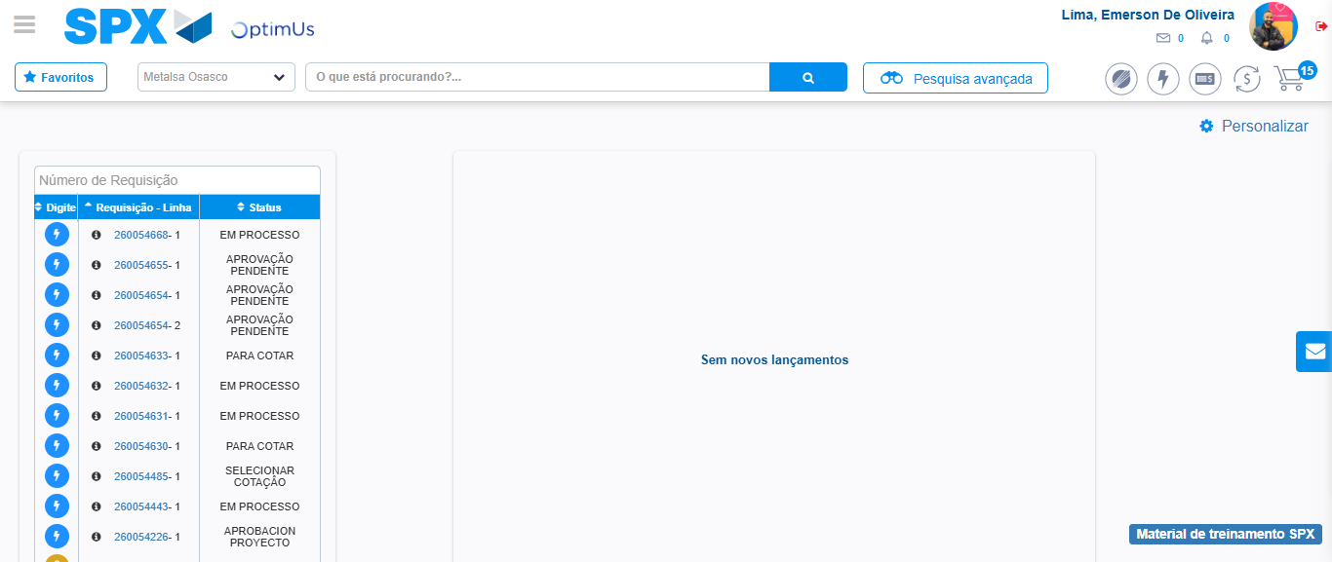Image file-name: QC_Testing-tc005_SPX_Dev5_Crear_Requisicion_Spot_Con_FAD_Tipo_Cobro_Project-1784669235397

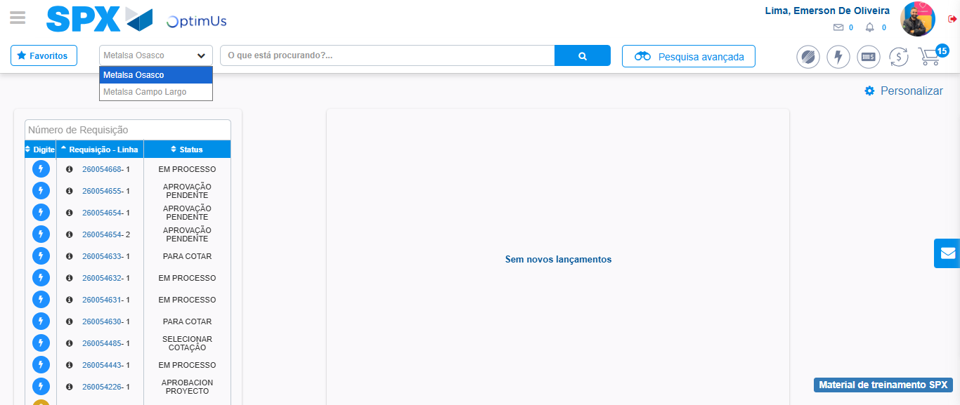Image file-name: QC_Testing-tc005_SPX_Dev5_Crear_Requisicion_Spot_Con_FAD_Tipo_Cobro_Project-1784669237979

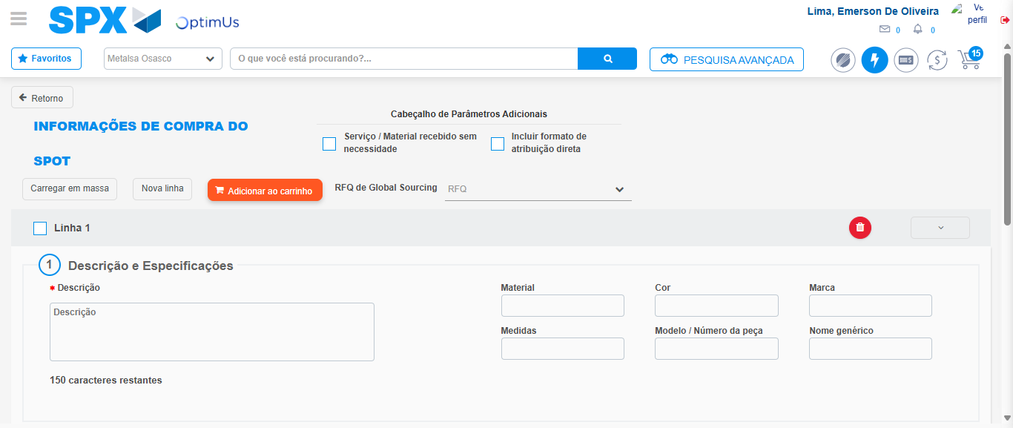Image file-name: QC_Testing-tc005_SPX_Dev5_Crear_Requisicion_Spot_Con_FAD_Tipo_Cobro_Project-1784669243894

Step 3 - Add FAD to Requisition: FAD Successfully Added
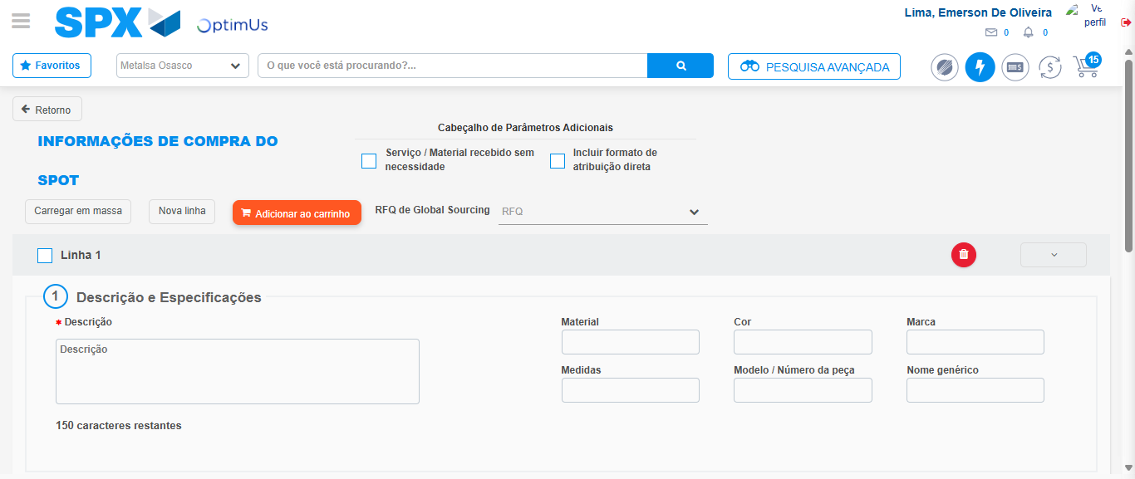Image file-name: QC_Testing-tc005_SPX_Dev5_Crear_Requisicion_Spot_Con_FAD_Tipo_Cobro_Project-1784669244255

Image file-name: QC_Testing-tc005_SPX_Dev5_Crear_Requisicion_Spot_Con_FAD_Tipo_Cobro_Project-1784669244470

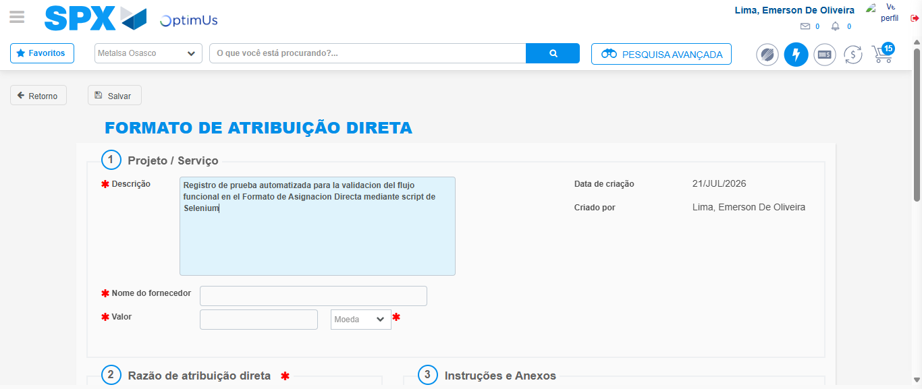Image file-name: QC_Testing-tc005_SPX_Dev5_Crear_Requisicion_Spot_Con_FAD_Tipo_Cobro_Project-1784669247496

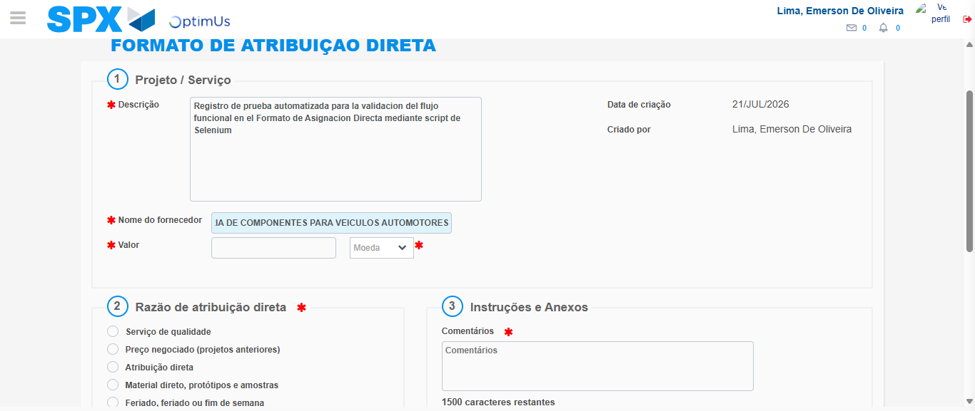Image file-name: QC_Testing-tc005_SPX_Dev5_Crear_Requisicion_Spot_Con_FAD_Tipo_Cobro_Project-1784669257698

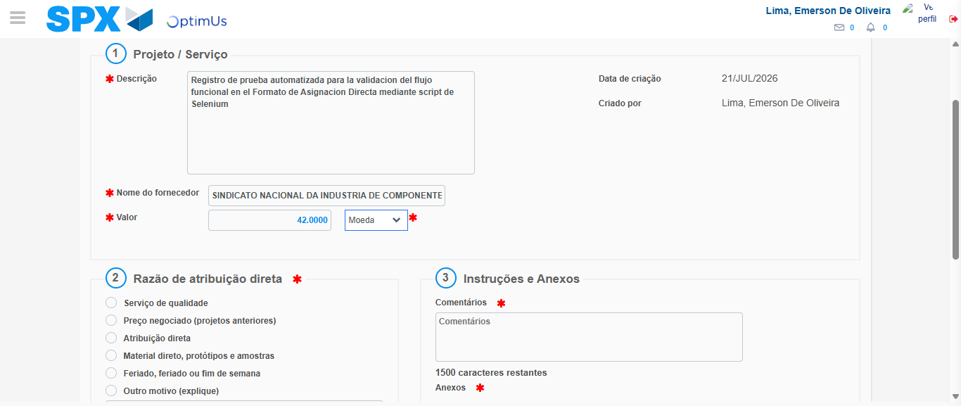Image file-name: QC_Testing-tc005_SPX_Dev5_Crear_Requisicion_Spot_Con_FAD_Tipo_Cobro_Project-1784669258211

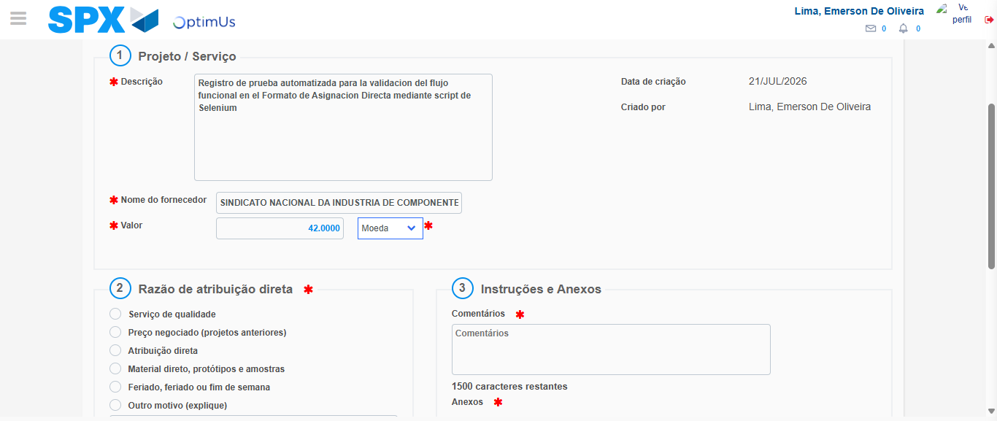Image file-name: QC_Testing-tc005_SPX_Dev5_Crear_Requisicion_Spot_Con_FAD_Tipo_Cobro_Project-1784669258452

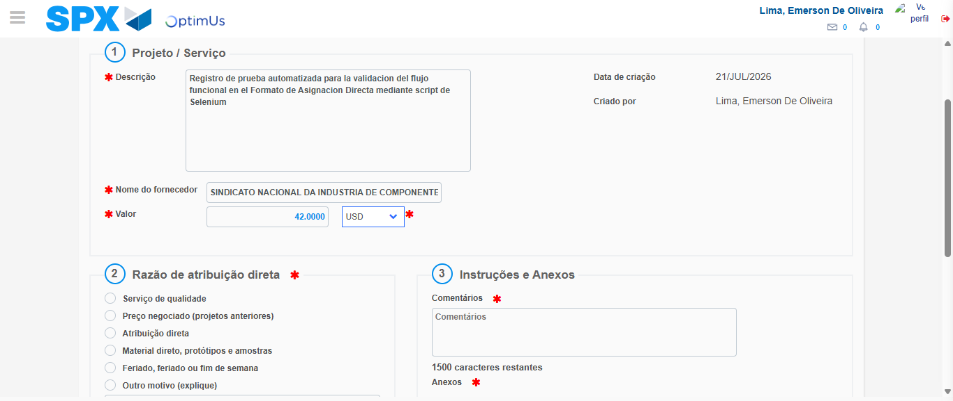Image file-name: QC_Testing-tc005_SPX_Dev5_Crear_Requisicion_Spot_Con_FAD_Tipo_Cobro_Project-1784669258907

Image file-name: QC_Testing-tc005_SPX_Dev5_Crear_Requisicion_Spot_Con_FAD_Tipo_Cobro_Project-1784669259108

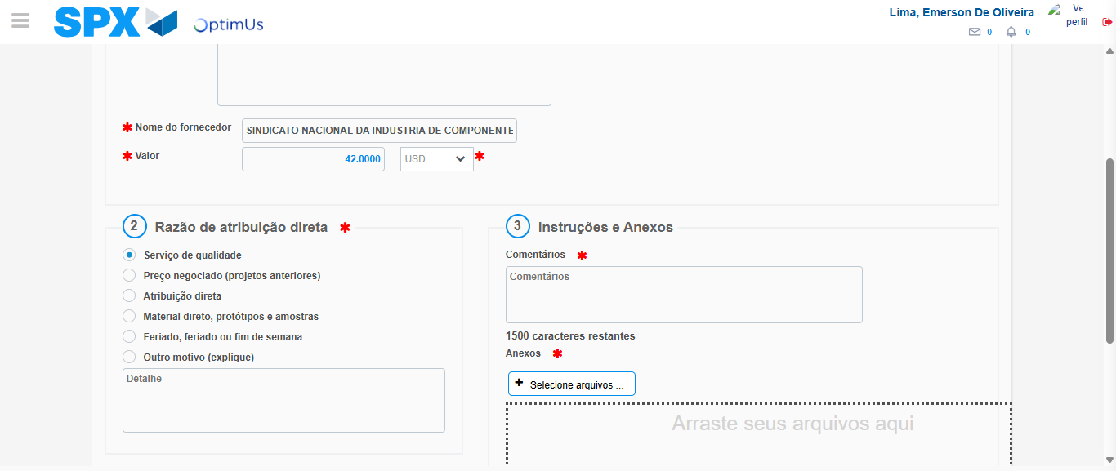Image file-name: QC_Testing-tc005_SPX_Dev5_Crear_Requisicion_Spot_Con_FAD_Tipo_Cobro_Project-1784669260024

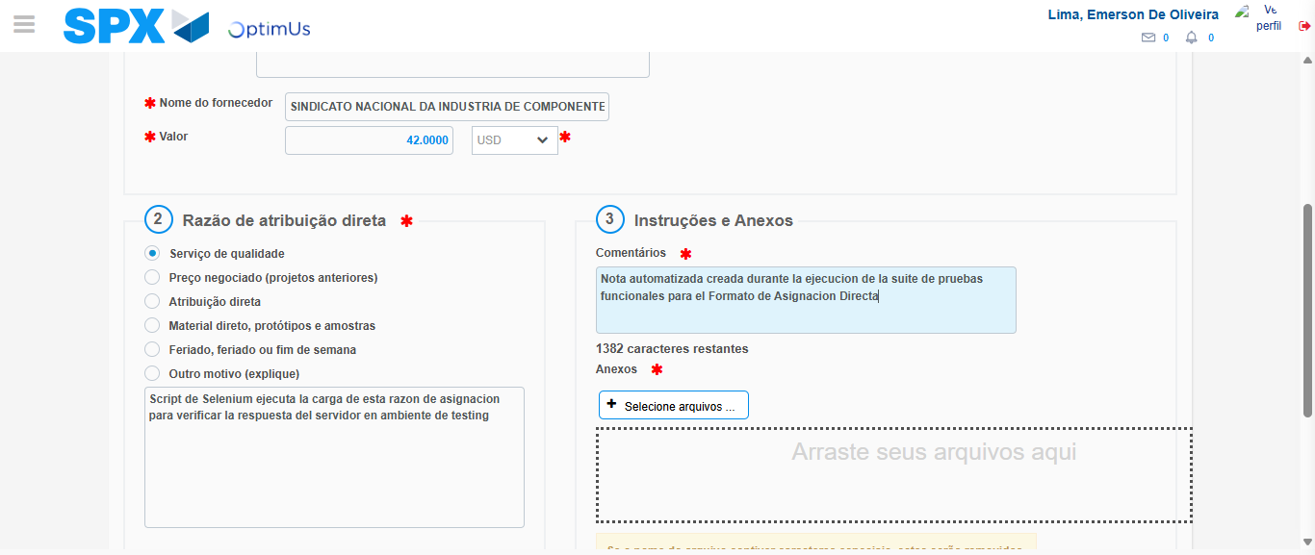Image file-name: QC_Testing-tc005_SPX_Dev5_Crear_Requisicion_Spot_Con_FAD_Tipo_Cobro_Project-1784669271108

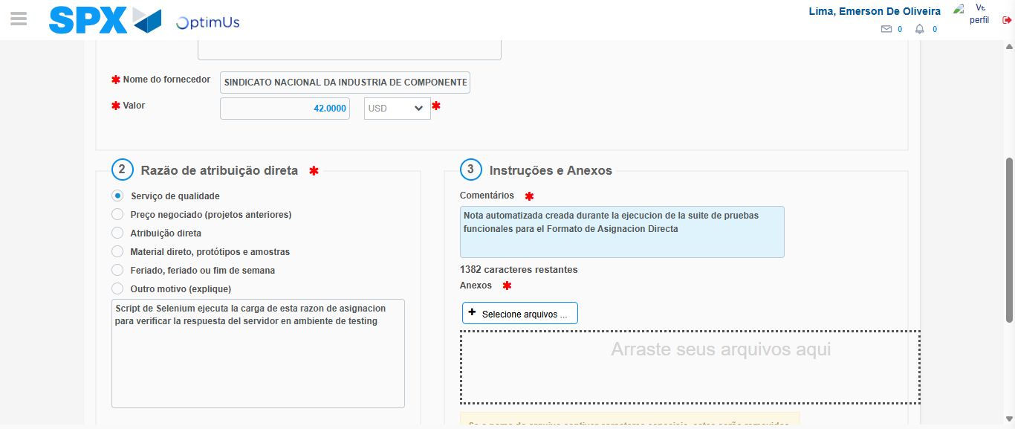Image file-name: QC_Testing-tc005_SPX_Dev5_Crear_Requisicion_Spot_Con_FAD_Tipo_Cobro_Project-1784669272029

Step 4 - Data Capture Spot Buy Requisition: Data captured correctly
Image file-name: QC_Testing-tc005_SPX_Dev5_Crear_Requisicion_Spot_Con_FAD_Tipo_Cobro_Project-1784669244255

Image file-name: QC_Testing-tc005_SPX_Dev5_Crear_Requisicion_Spot_Con_FAD_Tipo_Cobro_Project-1784669244470

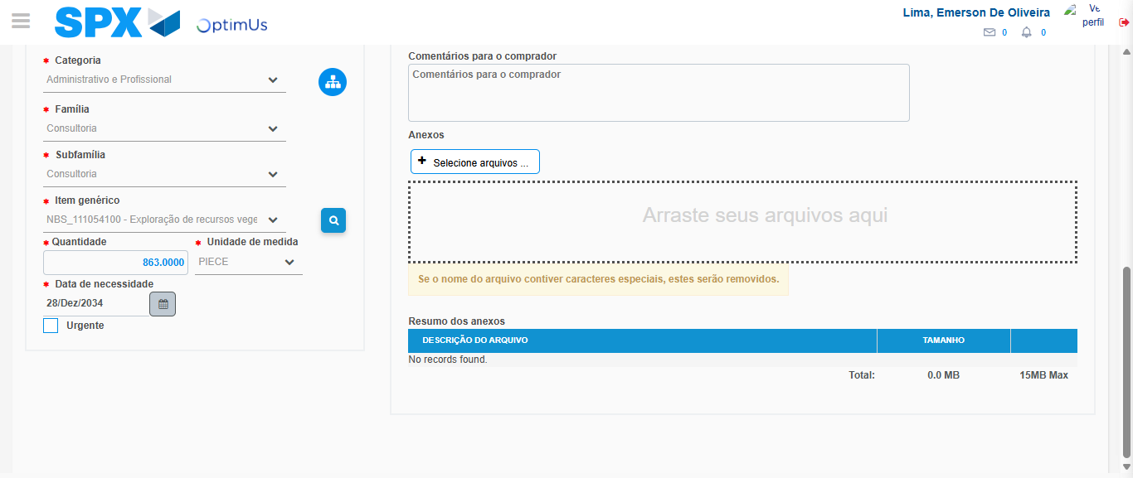Image file-name: QC_Testing-tc005_SPX_Dev5_Crear_Requisicion_Spot_Con_FAD_Tipo_Cobro_Project-1784669286929

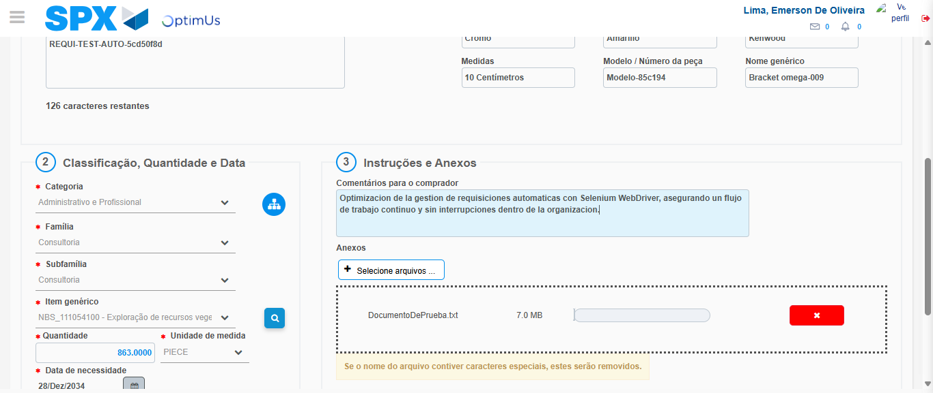Image file-name: QC_Testing-tc005_SPX_Dev5_Crear_Requisicion_Spot_Con_FAD_Tipo_Cobro_Project-1784669287869

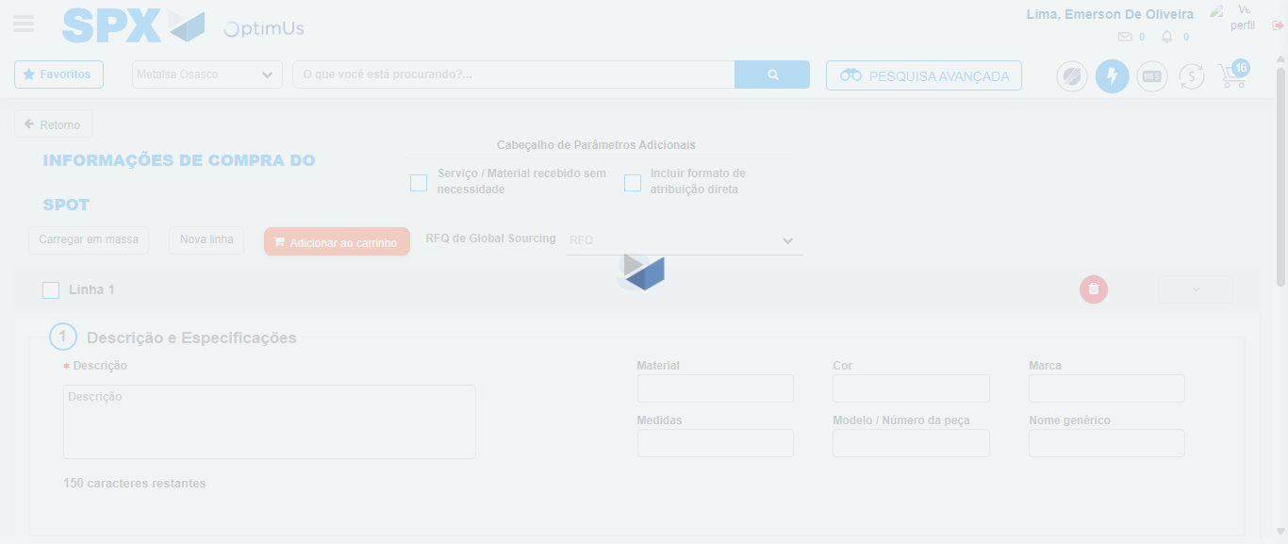Image file-name: QC_Testing-tc005_SPX_Dev5_Crear_Requisicion_Spot_Con_FAD_Tipo_Cobro_Project-1784669295657

Step 8 - Return to Main Page SPX : Return to Main Page SPX
Image file-name: QC_Testing-tc005_SPX_Dev5_Crear_Requisicion_Spot_Con_FAD_Tipo_Cobro_Project-1784669235397

Image file-name: QC_Testing-tc005_SPX_Dev5_Crear_Requisicion_Spot_Con_FAD_Tipo_Cobro_Project-1784669237979

Image file-name: QC_Testing-tc005_SPX_Dev5_Crear_Requisicion_Spot_Con_FAD_Tipo_Cobro_Project-1784669243894

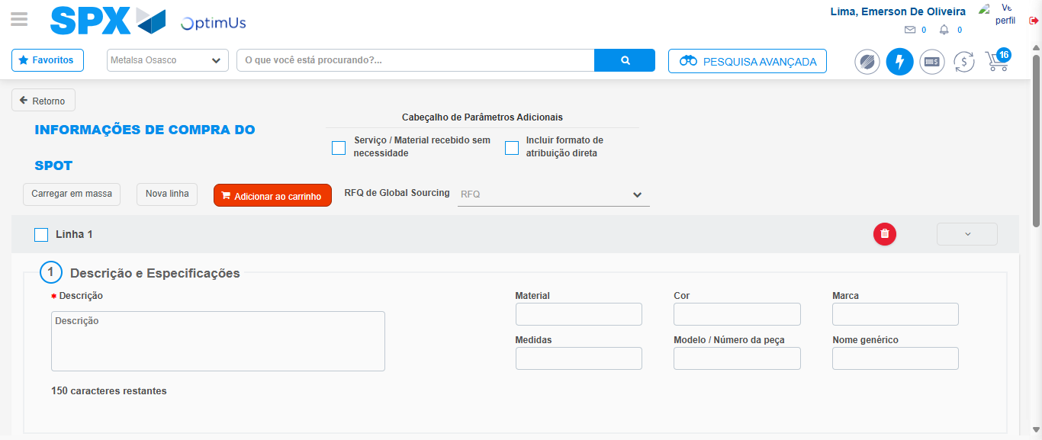Image file-name: QC_Testing-tc005_SPX_Dev5_Crear_Requisicion_Spot_Con_FAD_Tipo_Cobro_Project-1784669298071

Image file-name: QC_Testing-tc005_SPX_Dev5_Crear_Requisicion_Spot_Con_FAD_Tipo_Cobro_Project-1784669298314

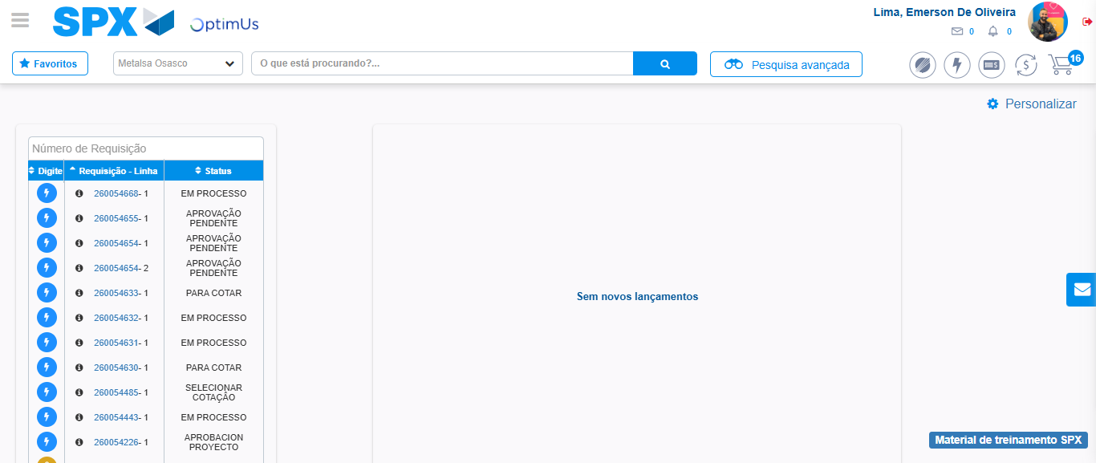Image file-name: QC_Testing-tc005_SPX_Dev5_Crear_Requisicion_Spot_Con_FAD_Tipo_Cobro_Project-1784669319405

Step 9 - Log Out : Log Out SPX
Image file-name: QC_Testing-tc005_SPX_Dev5_Crear_Requisicion_Spot_Con_FAD_Tipo_Cobro_Project-1784669319609

